**CAAP Quarterly Report**

**June/30/2022**

*Project Name: Pipeline Risk Management Using Artificial Intelligence-Enabled Modeling and Decision Making*

*Contract Number: 693JK32150001CAAP*

*Prime University: Rutgers University*

*Prepared by: Bingyan Cui (PhD student), Dr. Jingnan Zhao (Postdoc), Dr. Hao Wang (PI)*

*Reporting Period: 4/1/2022 – 6/30/2021*

**Project Activities for Reporting Period:**

*ILI Data Collection and Preliminary Analysis*

In this period, the ILI data from another industry partner were used to conduct analysis of corrosion defects, including the original corrosion data and maximum corrosion depth growth prediction. The steel transmission pipeline is about 12 miles that was originally constructed in 1974. Based on the history of replacements and relocations, the pipeline was divided into several segments (a-g). The general information about the pipeline is listed in Table 1.

**Table 1.** General information about the pipeline

|  |  |  |  |  |  |
| --- | --- | --- | --- | --- | --- |
| Line segment No. | Length (feet) | Outer diameter (in.) | Wall thickness (in.) | Pipe grade | Year installed |
| a | 51,241 | 30 | 0.562 | 5L×42 | 1974 |
| b | 613 | 24 | 0.438 | 5L×42 | 1974 |
| c | 772 | 20 | 0.375 | 5L×42 | 1982 |
| d | 5,910 | 30 | 0.562 | 5L×60 | 2005 |
| e | 1,698 | 30 | 0.562 | 5L×60 | 2005 |
| f | 41 | 6.625 | 0.28 | 5L×42 | 1974 |
| g | 654 | 30 | 0.562 | 5L×42 | 2002 |

The in-line inspection (ILI) data for this pipeline are obtained from Magnetic Flux Leakage (MFL) inspection tools in 2005, 2012 and 2016, respectively. The external corrosion defects were selected for analysis since it is the major defect observed. The MFL tool provides measurements of wall thickness and metal loss depth/length/orientation. The count of corrosion defects from three inspections is shown in Table 2. It can be seen that the total number of external corrosions increases from 2005 to 2016 due to the generation of new defects.

To compare the distribution of corrosion defects, the number of these defects in each girth weld number along the pipeline was counted, as shown in Fig. 1. Each girth weld represents 30-40 ft pipe length. As expected, the numbers of corrosion defects in different segments were found greater in 2016 as compared to the previous two inspections, which is consistent with the change in total number of defects. The increase of corrosion defects around several girth weld numbers was found more significant, indicating the environment for high corrosion potential. However, the soil survey data were not available.

**Table 2**. Number of external corrosion defects found in different inspection years

|  |  |
| --- | --- |
| Inspection year | Defects count no. |
| 2005 | 792 |
| 2012 | 1345 |
| 2016 | 2508 |

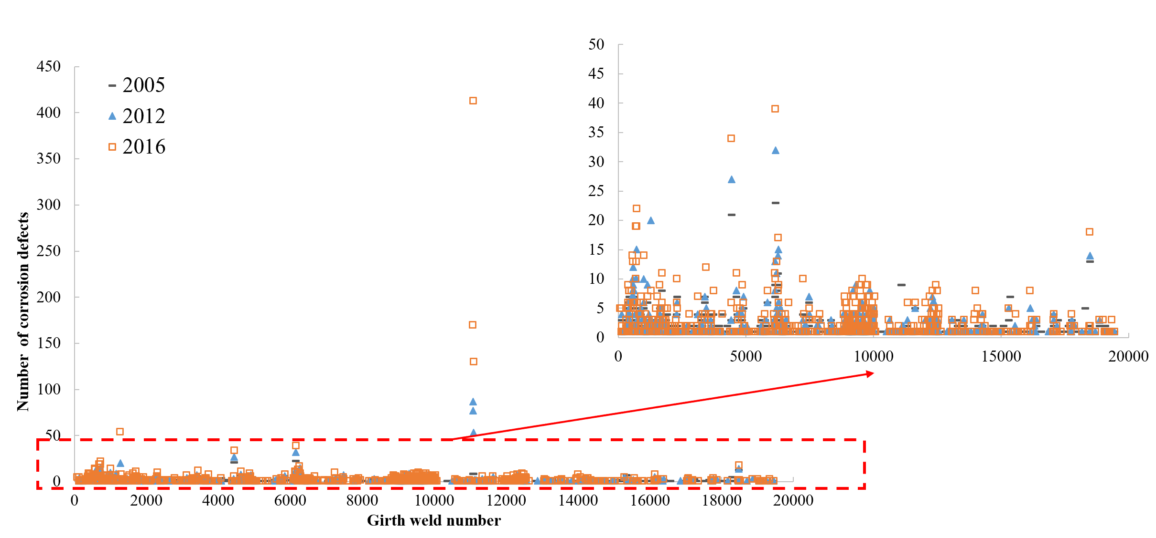

**Fig. 1** Number of external corrosion defects along the pipeline in different inspection years.

To better understand of the severity level, all the corrosion defects were analyzed using k-means clustering based on defect depth and length. In the same cluster, the characteristics of defect depth and length are more similar than those in other clusters. The clustering results are shown in Fig. 2 and the number of defects are listed in Table 3. The results show that the corrosion defects can be divided into four clusters along the length of pipeline, which indicate the potential impact of soil environment on external corrosion. The number of defects in each cluster tends to increase over years, and this trend is the most significant in cluster 3.

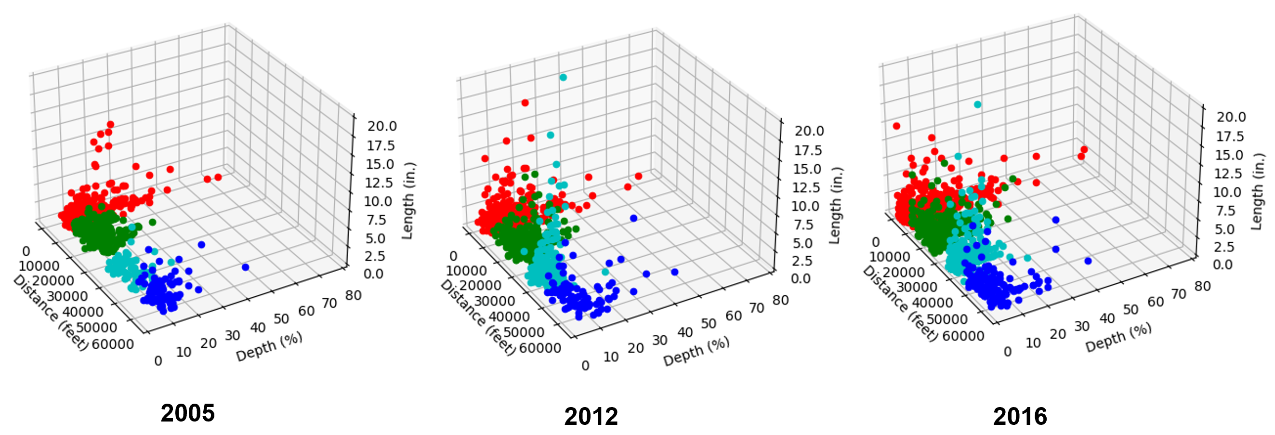

**Fig. 2** Clustering plot of corrosion defects in different inspection years.

**Table 3**. Number of external corrosion defectsin different clusters

|  |  |  |  |
| --- | --- | --- | --- |
| Cluster | Inspection year | | |
| 2005 | 2012 | 2016 |
| 1 | 273 | 376 | 588 |
| 2 | 306 | 331 | 426 |
| 3 | 124 | 535 | 1332 |
| 4 | 89 | 103 | 162 |

Furthermore, statistical analysis was performed on the original dataset to compare corrosion depth that is represented by the percent of wall thickness. The scatter plots along the pipeline, density plots, and Bix boxplots are shown in Fig. 3. Although the number of defects increased from 2005 to 2016 (as shown in Table 1), the average corrosion depth did not increase. This was because the generation of large numbers of small defects in 2012 and 2016, which reduced the average corrosion depth. In addition, the decrease of corrosion depth from the 2005 to 2016 may be attributed to the repairs of pipelines.

Ideally, the corrosion depth would increase over years if no repair is placed. However, this trend was not observed at each inspection location. The variations can be caused by the changes in measurement accuracy and reporting criteria of ILI tools and the advances in technology in different inspections. Another reason of causing this variation is the mismatch of absolute distance from different inspections. Therefore, the original dataset was processed to obtain the reasonable subsets for further analysis.



**Fig. 3** Statistical plots of external corrosions (a) Scatter plot of corrosion depths along the pipeline; (b) Density plot of the corrosion depth; (c) Boxplot of the corrosion depth.

Further data processing was conducted to analyze the growth pattern of metal loss. First, the relative distance to the girth weld number was used to locate the defect location; Second, for the defects at the close locations, only the data that shows the continuous growth trend of maximum corrosion depth over inspection years were selected. That is to say, if the maximum corrosion depth keeps growing, it can be considered that this location was most susceptible to external corrosion. This approach resulted in a smaller and more conservative data subset including 1,220 data points, which was used to analyze the growth of maximum corrosion depth. The density plot of the extracted data subset is shown in Fig. 4. The general statistics of the data subset are shown in Fig. 5, including minimum, maximum, mean, and standard deviation. It can be seen that the maximum corrosion depth follows an increasing trend that can be used for prediction of growth rate.



**Fig. 4** Density plot of extracted subset with maximum corrosion depths.

**Fig. 5** General statistics of maximum corrosion depths in the subset

Considering that the Gumbel distribution is particular useful in representing the probability distribution of the maximum value, the corrosion depths in the subset were ﬁtted to the Gumbel distribution, as shown in Equation (1). The theoretical and empirical quantiles were compared through the histogram and Q-Q plots as shown in Fig. 6. The data points are close between theoretical and empirical quantiles, indicating the fitted Gumbel distribution has high accuracy. The fitting parameters are shown in Table 4.

 (1)

where, Gt(*z*) is the densify when the maximum corrosion depth is equal to *z*; and *z* is the maximum corrosion depth.



**Fig. 6** Theoretical densities and empirical histograms (left), and the Q-Q plot of the fitted data to the Gumbel Distribution (right) in different inspection years

**Table 4.** Fitting parameters of Gumbel distributions

|  |  |  |
| --- | --- | --- |
| Inspection year | Location parameter (*μ*) | Scale parameter (*σ*) |
| 2005 | 16.53 | 7.68 |
| 2012 | 18.83 | 7.96 |
| 2016 | 22.47 | 8.97 |

Using the linear regression to fit the Gumbel distribution parameters over the inspection year, the fitted line can be seen in Fig. 7. It can be found that the location and scale parameters have an increasing trend that indicates the growth of maximum corrosion depths. The linear model can be expressed in Equation (2) and (3). After obtaining the two parameters, the Gumbel distribution can be used to calculate the density of maximum corrosion depth at the year of interest.

*μ*(*t*)=0.5161*t*-1018.7 (2)

*σ*(*t*)=0.1085*t*-210.1 (3)

where, *μ* is the location parameter; *σ* is the scale parameter; and *t* is the inspection year.



**Fig. 7** Fitted lines of Gumbel distribution parameters (a) location parameter; (b) scale parameter with respect to inspection year.

In addition to maximum corrosion depth, the axial and circumferential locations of defects are analyzed. Then density plots of the relative locations to girth welds and the orientation angle were plotted for all the external corrosion defects, as shown in Fig. 8. It was found that external corrosion was more likely to occur at 20-30 feet relative to each pipeline joint. The orientation angels were around 180° that indicated external corrosion would happen at the bottom of steel pipe.



**Fig. 8** Density plots of (a) longitudinal location of corrosion defects; (b) circumferential location of corrosion defects.

**Project Activities with Cost Share Partners:**

Cost share is provided by Rutgers University during this quarterly period as budgeted in the proposal.

**Project Activities with External Partners:**

The PI and graduate student had a follow-up meeting with the industry partner on April 18 to discuss the in-line inspection (ILI) data to clarify some questions. The preliminary data analysis in this report was also shared with the industry partner for comments.

**Potential Project Risks:**

N/A

**Future Project Work:**

The research team will start working on Task 3 Data-Driven Probabilistic Modeling of Defects. The purpose is to analyze the collected ILI data through unsupervised and supervised machine learning algorithms to predict defect growth.

**Potential Impacts to Pipeline Safety:**

The in-line inspection data will be used to develop probabilistic growth models of pipeline defects, which can aid pipeline operators better predict failure risk and make repair decisions.